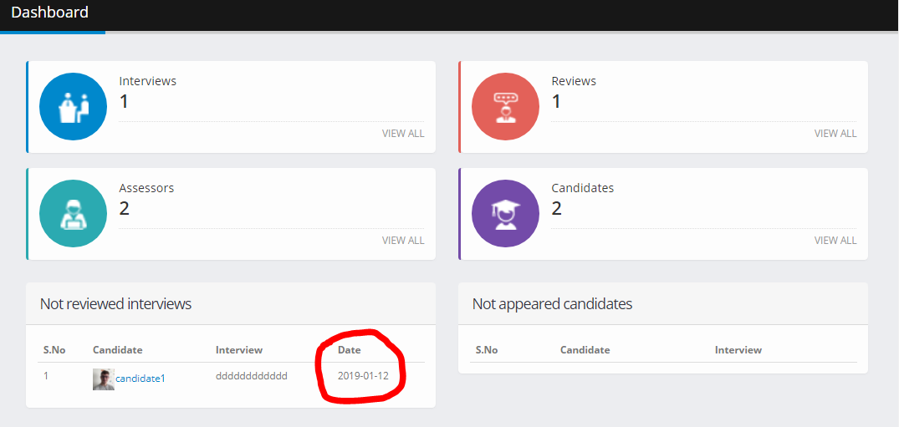

Date format. This have you seen it should be DDMMYYYY. ok

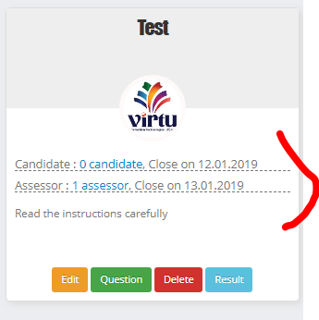

The app should not allow dates that have passed. Only current and future dates must be allotted.

Today is 14-01-2019. But see we are able to create an interview which ends on 12-01-2019 and the assessor date is also 13. The app shuld not allow previous days to be allowed while creating interviews and assessor end date.

Ok ,

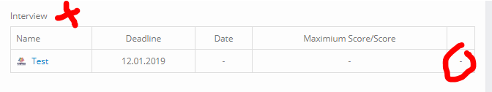

Add remove interview button has become dysfunctional. It should not be active from candidate login but from admin login it must work.

Why have you removed this feature. We are not able to add or remove interviews now from admin. Let me show you.

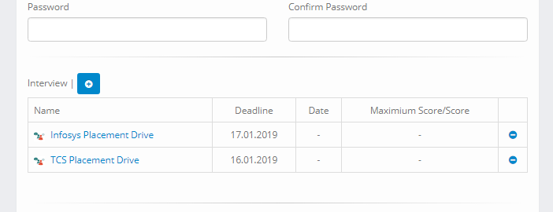

Currently only 1 interview at a time can be deleted. We are not able to delete more than 1 interview at a time for any candidate. This was the issue that neede to be fixed.ignore this

Check – functionality, 1 last interview can not be deleted.

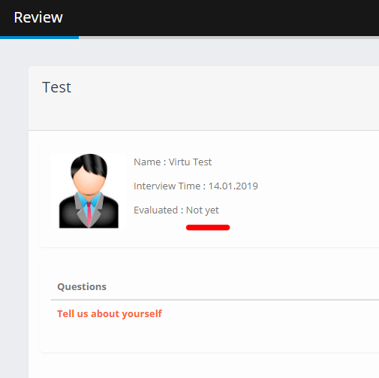

Appears even after the interview has been reviewer. If the interview is not reviewd then it not shoe “Not Reviewed” ok. But this interview has been reviewed, so it should show Reviewed. ok.

Mobile number cannot be less than 10 digits.

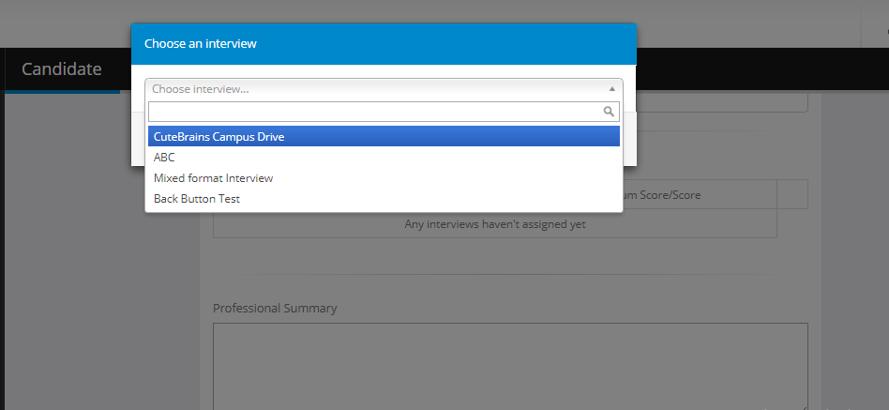

Can we select all the 3 interviews at 1 time only like we assign more than 1 assessor at a time. Can this be done? It is not very important but it will make the app very smart. I will check one more time.. Thanx ignore as we are not adding interviews form candidate page.

Not done

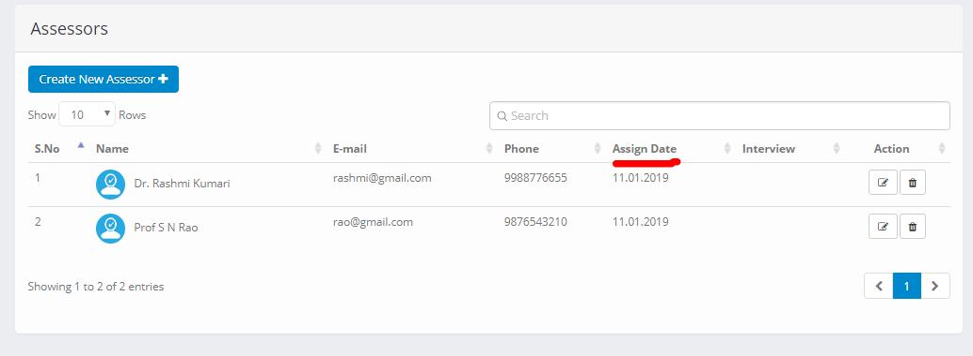

Why have to removed “Assign Date” column. You have removed this column. The assign date column is not important owing of an assessor can . ok, leave it.

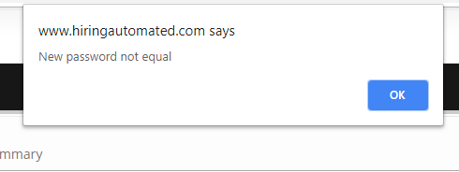

Change text to Password Mismatch. Just change the text.

**In Mixed Question Type** see this is an interview where we add videos, audios, single, multi, image every thing in question and response type is also not just video. So here we are facing few problems.

1. In multi/single type question: The candidate must not see the marks at the time of giving the interview. In single and multy type question, when the candidate gives his response, a message appears which shows that how much marks has the candidate achieves. It should not appear there. Let me demonstrate it to you.
2. Interview should end automatically, currently we have to click on the complete button.
3. “My Score” must not be visible before the interview has been reviewed. In mixed question it shows 5 even before the interview has been reviewed. Also the question is re-reviewed by the assessor and re evaluated.

Bulk upload of assessors through CSV.

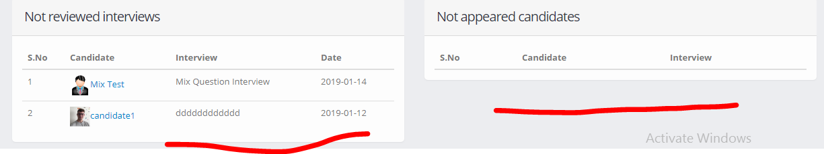

This functionality is still not functional. If a candidate is allotted 3 interviews then his name appears in “Not appeared candidate” but when he given only 1 interview, then remaining 2 files are also deleted. This we had discussed earlier also, in case you do not understand then let me know, I will explain it to you.

Add freeze window option when the candidates starts the interview.